

Software Design Document

LabFinder

by

Joe Caruso

12/2/15

Introduction

Purpose

This document will serve to provide an understanding and overview of the application LabFinder. LabFinder is a web application which allows college students or faculty to search for a classroom or lab space availability based on search criteria. The app will rely on a server running MongoDB for a database, and will be accessible to anyone through their Champlain email. The data will contain information about all classes and classrooms, and provide a simple and intuitive form for searching or filter data. Based on user inputs, available classrooms will be returned in a simple, and possibly interactive way.

Scope

The working prototype for LabFinder will be designed as a web application. It will be targeted towards college students, and specifically students who use on campus computer labs for school work and school projects. This project will benefit two groups of people: Students and Library/ Technical Facility. Students will benefit because they will be able find the closest lab that meets their given time frame, and/or software needs. Faculty will benefit will because they can direct people with questions about lab availability directly to the app LabFinder.

System Overview

LabFinder will use Mongodb to interact with a database containing data provided by Champlain College. This NoSQL database was chosen because of its simplicity, and also the dynamic nature of the data which it manipulates.

Terminology

Mongodb – A form of a NoSQL database that is document based

Mongo – The shell interface designed to communicate directly to the database

Mongod – the primary daemon process which handles data requests, manages data access, and performs background management operations on the MongoDB system.
Mongo Java driver – a Java library which is designed to help communicate with a Mongo database.
NoSQL – A schema-less database, or non-relational database.
FreeMarker - templating language that allows an application to create HTML views using MVC

SparkJava - a micro web framework that allows the application to set up routes that map urls so when a request comes in for a specific url, the application can handle it, and respond via HTTP

MVC – Model view controller, a software pattern for implementing a user interface

Javascript – a dynamic programming language used for interpreting data

JVM – a virtual machine that allows a computer to run a Java program

Overview

This document is separated into different sections: Design, Data Structure, System Structure, Interface, and References. Together they give a wholistic representation of LabFinder and how it functions.

Design Considerations

General Constraints

- LabFinder will rely on some server running a Mongodb database.
- Accessibility and ease-of-use is critical to the usefulness of LabFinder. The apps purpose is to relay information, and it cannot do this effectively if people are unable to use it.
- In order to reduce privacy concerns, the app should only be assessable to someone with the proper college credentials (joseph.caruso@mymail.champlain.edu.)
- The database will rely on 2 major collections: classes, and classrooms. Classroom data will be filtered then combined with classes that use those classrooms, according to date and time filters.
- LabFinder will only rely on one server so I do not have to worry about consistency issues.
- The User will need internet access to use the app.

Assumptions and Dependencies

I have made the assumption that building a web app would be more assessable than building an IOS or Android app. Although this would limit the functionality, it would be more easily available for all devices.
I assume that it is on occasion difficult to find a lab to work in, and that there is a desire for some consolidated application to deliver this kind of information.
The ability to search for classrooms based o class schedules will be implemented first, and as time permits, additional feature will be added such as, software, number of students currently logged on in the room, location proximity, etc.

Goals and Guidelines

This project has an emphasis on simplicity. This app will only be useful if it is simple to use.
Additionally it must also be effective, it must be able to deliver useful information to the user.
Speed will be more important than memory use. The amount of data that will be queried is not huge, so it will not be a factor.
LabFinder may resemble the Event Management Systems Room Scheduling application. My application will have some different features, will not be designed for room reservations, and will be targeted towards a different audience.

Data Architecture

Data Structure

The majority of the data in the database will be represented by a few types of collections: Classes, Rooms, Buildings, Computers, Images, and Errors. Each collection will contain documents which represent an element of that collection.

Generally, a document in these collections will look like such:

Class

Variable name | Type | Description | Ex.
Class_id | String | A unique identifier for the class.
Class_name | String
room_id | String[] | A unique identifier for a room document. Made as an array in case of multiple class days in different rooms. | (see classroom document)
day | String[] | A string describing the day of the week. Made as an array in case of multiple classes on different days. | {“Monday”, “Wednesday”}
time | String[] | A string indicating the start time and end time of a class. Start and end time are deliminated by a dash character ‘-‘. Made as an array in case of multiple class days in at different times. | {“9:30-10:45”, “3:30-4:45”}

Room

Variable name | Type | Description | Ex.
room_id | String | A unique identifier for a room document. | -
room_name | String | The name of the room or area | “Wick 101”
building_id | String | A unique identifier for a building document. | -
num_computers | int | An integer describing the number of computers in that room. | -
Whiteboard | Bool |  | -
Projector | Bool |  | -
Chalkboard | Bool |  | -
num_windows | int |  | -
PencilSharpener | bool |  | -
WaterFountain | Bool

Building

Variable name | Type | Description | Ex.
Building_name | String | The name of the building. | {“Hauke”}
building_id | String | A unique identifier for a building document.
location | String | Gps location of the building

Computer

Variable name | Type | Description | Ex.
computer_name | String | The name of the computer. | {MIC2ND-32}
computer_id | String | A unique identifier for the computer
room_id | String | A unique identifier for the room that the computer is located in. | -
Image_id | String | A unique identifier for an Image document
Type | Int | An integer representing what type of OS the computer is running.

Image

Variable name | Type | Description | Ex.
Image_id | String | Unique identifier for the Image document.
Software | String[] | An array of strings containing the names of the software used for this image. | {“Visual Studio”, “MatLab”}

Errors

Variable name | Type | Description | Ex.
error_id | String | Unique identifier for the Image document.
Doc_id | String | Unique identifier for the document which has an error.
collection_name | String | Name of the collection that the document is located.
Report | String | A description of the error reported by a user.

Data Format

Each document is stored in JavaScript notation. Since MongoDB is non-relational, each document within a collection may not be formatted the same. For example, the second floor of library is a room, but since it is not a classroom, it will not contain data about whiteboards or projectors rather than being set to false. Some rooms will not have any computers, and will have no num_computers variable.
To maintain consistency, the documents will be maintained in a very similar way, but deviation from this will not be an impediment to the system.

System Architecture

This application will be built using Java. This application will use SparkJava and Freemarker to help build the web application. SparkJava is a micro web framework that allows the application to set up routes that map urls so when a request comes in for a specific url the application can handle it and respond via HTTP. Freemarker is a templating language that allows the application to create HTML views using MVC.
This all runs inside JVM. The application uses a Mongo Java driver to make a TCP connection to MongoDB.

The user communicates with the JVM process running LabFinder in order to use the LabFinder application.

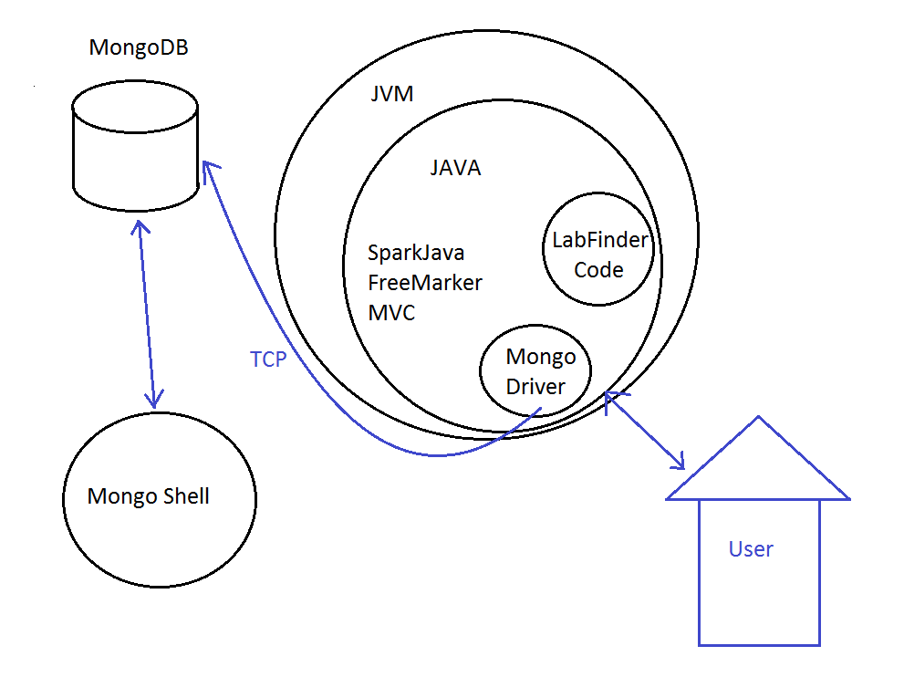

Interface

After logging in, or using Champlain's login authentication, you'll be presented with a page containing a keyword bar, and sets of check boxes which will act as filters for querying the database. After a search the user will be returned a list of areas on campus that fit their needs. You will be able to view more detailed information about each area, while also being given the opportunity to see a map of campus to show where exactly that area is.
In each detail section, there will be an option to report an error about the area description. Error reports will be created and added to the database for review.

References

Online Courses

M101J: MongoDB for Java Developers https://university.mongodb.com/courses/M101J/about

Staff

Tara Arneson – helped me with obtaining information for courses

